Which front-end framework should you use?

Applied research document



Done by: Stanislav Petkov (4222024)

Class: S3-CB04

Contents

Introduction 3

Which framework should you go for? 4

1.1 Which are the most popular front-end frameworks currently? 4

1.2 Pros and Cons of the most used frameworks 5

React 5

Angular 5

Vue.js 6

Conclusion 7

References 8

# Introduction

In the beginning of this semester, everyone had to choose which front-end framework/library he is going to use for the development of their projects. We were directed into using React, so me and most of my classmates chose it, at the time I thought that this was probably the best possible choice, because we had it recommended by our teachers, but there were some students that decided to go with Angular as well, so that got me thinking on whether I made the correct decision in going with React or there is a better one available. Therefore, I decided to conduct a small research myself and figure out if my decision was the right one.

# Which framework should you go for?

## Which are the most popular front-end frameworks currently?

In the chart below are displayed the 3 most downloaded frameworks through the npm (NODE PACKAGE MANAGER) this year are: React, Angular and Vue.js. The statistics show that react has a huge lead over the other two most popular frameworks, which are very close in numbers, but when we add the people that still use the old Angular framework, it makes it a clear favorite over Vue.js.

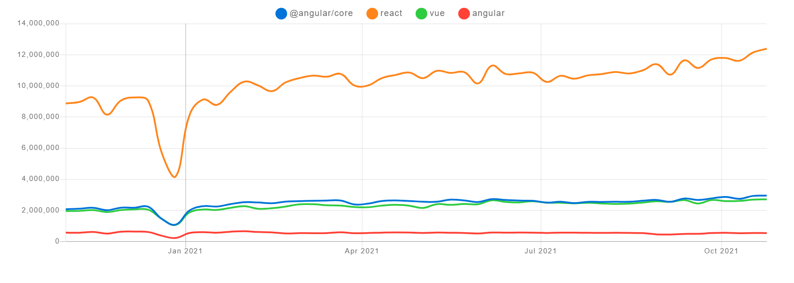

For a clearer visual representation, we can look at the chart below, where again the recent number of downloads of each framework are compared but in percentages. Two thirds of web developers choose React over the other popular front-end frameworks.

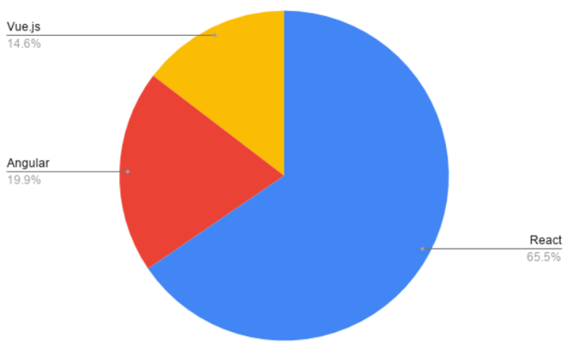

## 1.2 Pros and Cons of the most used frameworks

### React

#### Advantages

In general, React is quite easy to pick up, if you are fast learner, you will be able to develop simple applications withing the first month of using it, due to the fact that it is overall a smaller framework compared to Angular and it allows you to use only the pieces that you need, so you don’t have to get familiar with multiple concepts from the get-go. In React, you can choose between functional and class-based components, which can make things a lot easier for people struggling with class-based components. You also can re-use your components, which can save a lot of time too. As the most popular framework out there, you have access to unlimited number of resources as well. Lastly, one of the big benefits of this framework is job-opportunities. More and more developers opt for learning React nowadays, because it can open many doors in the software world, with its huge popularity more and more companies require knowledge of React, thus knowing it will greatly increase your chances of employment.

#### Disadvantages

One of the main disadvantages when working with React is that developing large complex applications can prove difficult. In React you have freedom to choose how you want to structure your application and in case everything is not thought out carefully or you lack experience with structuring your own applications, then things can get messy very quickly. The other big disadvantage of the framework is that you can only pass data from parent to their children’s components and not the other way around as well.

### Angular

#### Advantages

Angular is one of the best frameworks out there for building complex large-scale applications since it allows you to make use of great features such as dependency injection, directives, static typing and many more, because it is built on TypeScript. Directives in Angular allow for implementation of declarative html template and you can use observables, which allows sending data from a child to a parent component.

#### Disadvantages

One of the biggest drawbacks of this framework is the long learning curve you need to deal with when starting with Angular (e.g., things like TypeScript can take a while to get used to). Another aspect that can prove difficult is that Angular is a strict framework, you can only use class-based components and need to always follow a set of rules. Lastly, the build bundle size is bigger compared to other frameworks, so loading times can be affected significantly.

### Vue.js

#### Advantages

Vue is a community-driven framework, there is an active community behind it, which is working to keep improving it every day. Good study materials/documentation about it are easy to find and the framework is beginner friendly as well. This framework allows you to use features from React like having a virtual DOM and some from Angular like directives and filters, which to a certain extent makes it the best of both worlds. Lastly, a nice advantage that can be mentioned is that it allows the developers to make their own custom directives/filters, which allows for more customization.

#### Disadvantages

The main drawback of Vue is that unlike Angular this framework is not suitable for developing large-scale projects due to the lack of financial backing from big companies (you can not get instant support when solving problems). The other big disadvantage is the lack of plugins: compared to the other two frameworks, this one supports much less plugins, which can really limit the developer’s ideas, unless they want to be constantly switching to other languages.

# Conclusion

In conclusion, each framework has positives and negatives over the others, if you are going to build small simple application then you should choose between Vue.js and React, on the other hand, if you are looking for something to support a large-scale project you should take up Angular. The other major difference is that React and Vue.js have a much faster learning curve compared to Angular, even though both are easier to pick up, React offers much more plugins and support compared to Vue.js. Not only that but the demand for developers capable with React is much higher than the one for Vue.js.

# References

Elliott, E. (2020, 12 31). *Top JavaScript Frameworks and Tech Trends for 2021*. Retrieved from https://medium.com/javascript-scene/top-javascript-frameworks-and-tech-trends-for-2021-d8cb0f7bda69

Potter, J. (2020, 08 25). *npm trends - react vs angular vs vue*. Retrieved from https://www.npmtrends.com/react-vs-vue-vs-angular

Samson, K. (2021, 02 17). *Which JavaScript Framework Should you learn in 2021?* Retrieved from https://dev.to/kalashin1/which-javascript-framework-should-you-learn-in-2021-27lj